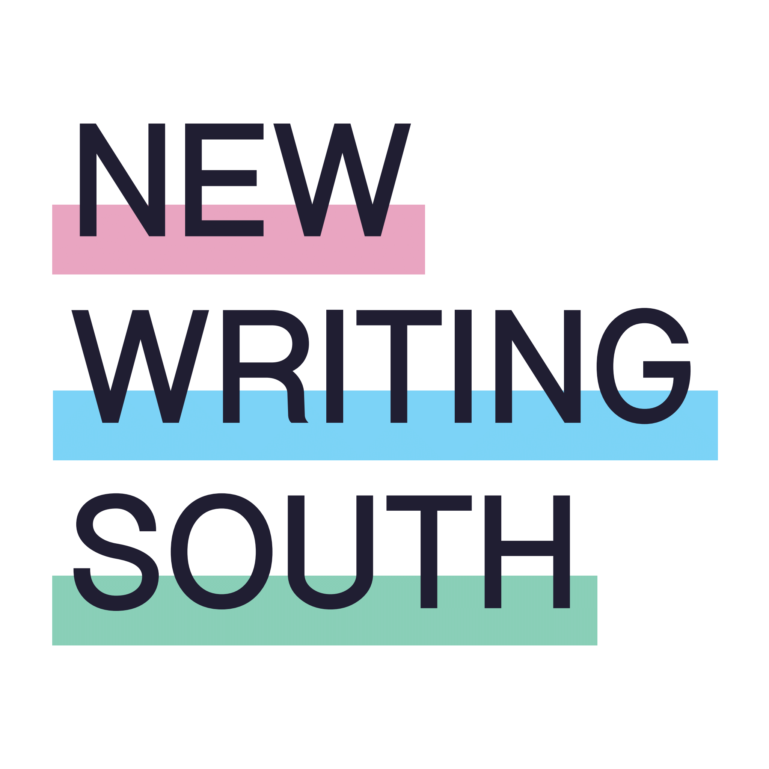
Crawley Creative Writing Microgrants

Background Information and Application Form

New Writing South is offering four grants of up to £3,000 each to Crawley writers, facilitators and/or community groups to run creative writing activities in the town. All writing/literature/storytelling activities are eligible. Your project might include, for example:
- writing workshops for adults (any genre - crime, memoir, nature writing, horror, history etc and any style – poetry, long fiction, short fiction, memoir)
- writing activities for children and or young adults
- community storytelling sessions - in libraries, museums, community centres, care homes, football clubs ….. anywhere that people gather
- children’s and young adult’s author visits in schools
- spoken word performances by local poets in clubs, youth centres, church halls.

Whatever your idea, as long as it involves creative writing activities that people can take part in, we’re inviting you to submit an application.

You do not have to have applied for funding before. There will be support available for people who have no community writing projects before.

Please note:

- The scheme is funded by Arts Council England to encourage and develop writing activities in Crawley so applicants must be based in, and activities must take place in Crawley.
- The scheme can only support new activity so you cannot apply to fund existing work.
- The activity must be complete by March 2027.
- To apply, you will need to explain your idea and supply a budget showing how the grant will be spent using this application form. You will need to keep a record of expenses throughout your project (eg invoices and receipts) and complete a monitoring form at the end explaining what you did, who took part, and how successful the activity was.

The deadline for applications is 5pm FRIDAY 3 JULY. Applications can be submitted online or by post. No applications will be accepted after the deadline, so if you are using Royal Mail please leave enough time to ensure delivery by 3rd July.

This information is available in large print on request and online at https://newwritingsouth.com/crawley-creative-writing-microgrants/

Crawley Creative Writing Microgrants: Application Form

Name:

Organisation (if applicable):

Email address:

Address:

Contact number:

Website (if applicable):

Amount of funding you are requesting: £

Information about your project

- What is the project or activity you would like the microgrant to support? The microgrant supports the development of creative writing focussed new work or activity. We cannot support work you are already delivering. (300 words maximum.)

- Why do you want to do this project or activity? (300 words maximum.)

- Please tell us about your experience of doing anything similar. If this is your first time, what do you think you might need help with? (150 words maximum)

- Who will take part in the activities eg the groups that might take part, the number of people? What do you hope they will get out of your project? (200 words maximum.)

- There will be networking events and workshops for successful applicants based on the areas you are interested in or would like to develop your skills. Please circle as many of the following options as you feel appropriate to you or your group. Please add any skills that are not listed.

- How to work with established writers Y/N

- How to evaluate your project Y/N

- How to plan future projects Y/N

- Advice about fundraising/applying for future grants Y/N

Any other support – please tell us if there are other areas we haven’t listed.

BUDGET

Please provide a budget of how you would spend the grant. You can apply for any amount up to £3000. Please continue on additional sheet if necessary.

ACTIVITY  This is what you’ll spend the money on, e.g. a writer to deliver a workshop, hire of a space or printing costs. | DETAIL  Do you know who you would pay to deliver this part of the project, or the venue you would like to hire, for example? It is fine if you do not know at this stage. | AMOUNT  How much will this part of the project cost? It may be an estimate but try to be as accurate as you can.
TOTAL COST

Is there anything else you want to tell us about your budget?

If your application is successful, you will be expected to collect monitoring forms from those involved in the project and write a short report about the activity. We will provide details and support with how to do that.

Please email your application form to hello@newwritingsouth.com or alternatively post it to: Crawley Micro-grants, New Writing South, Crawley Micro-grants, The Old Courthouse, 118 Church Street, Brighton, BN1 1UT.

Please note – all applications must be received by 5.00pm on Friday 3rd July. Applications received after this time cannot be considered.

