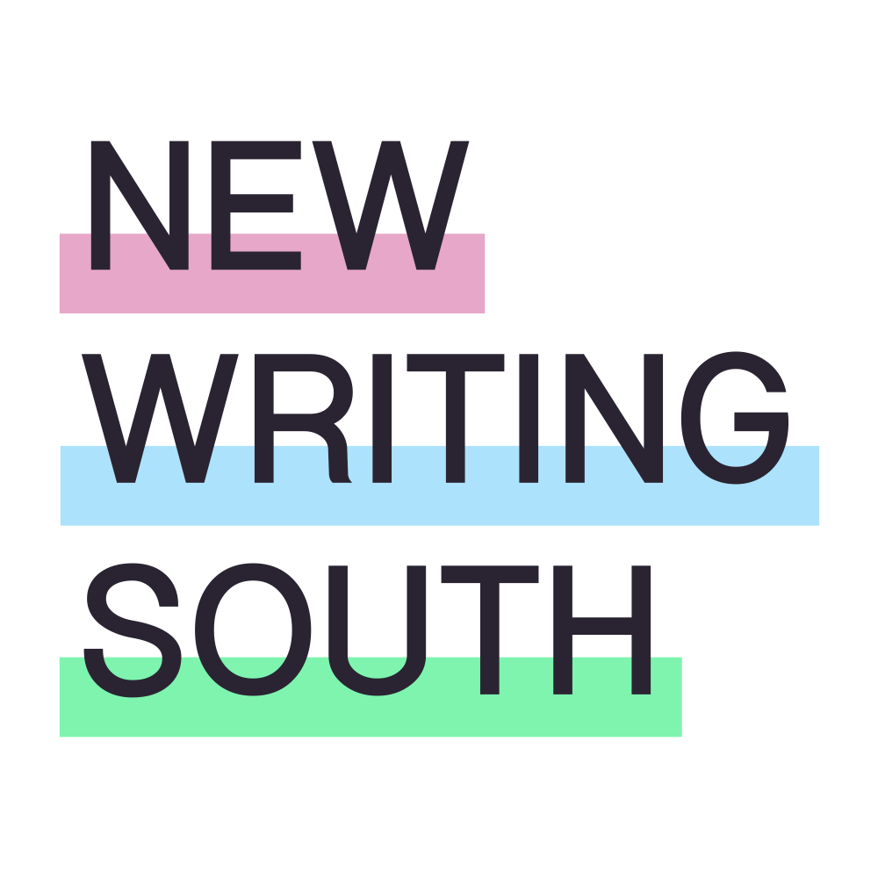

TRUSTEE RECRUITMENT PACK
FEBRUARY 2026

Welcome to New Writing South and thank you for your interest in becoming a Trustee of our charity. We are a literary development organisation working across South East England to create opportunity for writers too often overlooked by mainstream publishing. We support a vibrant writing community across the region, help develop the careers of gifted Global Majority writers, amplify working class voices in literature and bring our best LGBTQ+ writing to an international stage. We believe diverse stories strengthen culture and shape the books that define our times.

Over the past 3 years we have made bold programming and business decisions that have seen New Writing South grow in stature and national reputation, and we are keen to build on this momentum. Strong governance, clear strategy and ambitious partnerships are essential to ensuring our work remains bold, resilient and sustainable so we are now seeking new Trustees with expertise in finance, business development, HR / People and Publishing who share our love of literature to help us make a real mark on the UK creative writing sector.

If you are interested in bringing skills to an organisation where you can help make an impact, we would love to hear from you. We welcome candidates with all kinds of personal and professional life experience, and genuinely believe that being a New Writing South Trustee will make that experience even richer.

Anna Hayward, Chair of Trustees

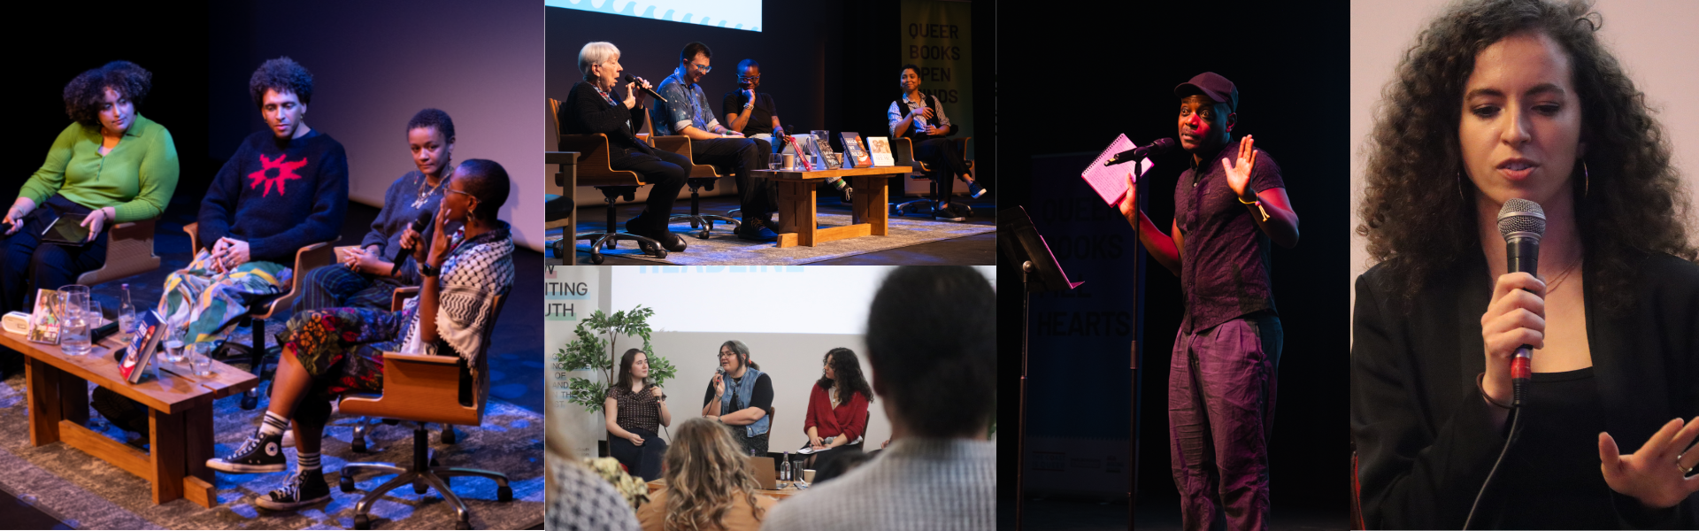
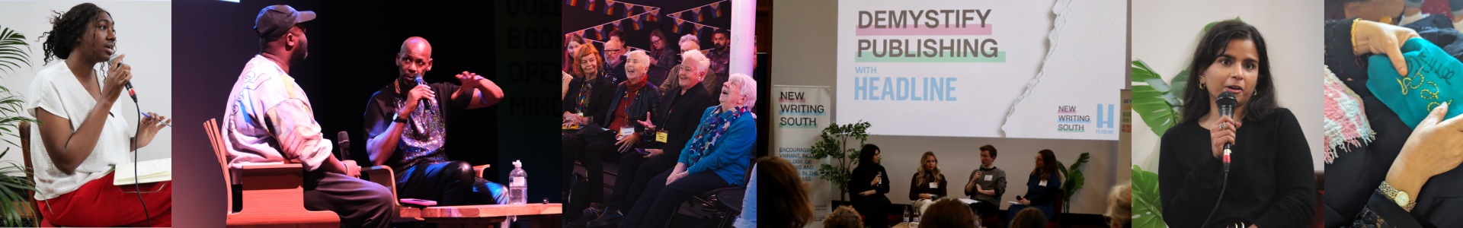

ABOUT NEW WRITING SOUTH
New Writing South is a charity and a company limited by guarantee. We receive funding from Arts Council England to support our core operations through their National Portfolio Organisation (NPO) programme, alongside grants from a range of other funders who support the delivery of literary festivals and projects. Based in Brighton, we work across the South East and nationally, in close partnership with a network of literature organisations. Our work supports writers to develop their craft, find community and reach new audiences.
Our flagship festivals - The Coast is Queer, the UK’s largest LGBTQ+ literature festival, and Forthwrite, the first and only festival for women writers over 50 - are recognised nationally and internationally for their timely championing of vital, diverse literary voices. Across our programmes, we focus on supporting Global Majority writers, LGBTQ+ writers and others with intersecting identities, including working-class, neurodivergent and older women writers.
We aim to empower underrepresented writers at all stages of their careers, giving them the space and platform to create work that reflects their lived experience and speaks honestly to their readers.
New Writing South is now seeking up to three new Trustees to join our Board and help us grow our vision while staying true to our values.

WE STAND FOR…
Creative expression
We believe that everyone has the right to creative expression. Writing is not a luxury; it is a powerful tool for articulating identity, challenging oppression, healing and imagining new futures.
Development
We value the craft of writing and the skills needed to build a career. We support writers to grow, creatively, professionally, and personally, so they can navigate an industry where access is uneven and opportunities are often inequitable.
Sustainability
We recognise that a long-term writing life requires stability, resources, community and care. We work to dismantle the financial and structural barriers that disproportionately affect marginalised writers though low cost - no cost opportunities.
Community and belonging
We cultivate inclusive and safe writing communities where writers can connect, collaborate and thrive. We strive to ensure under-represented writers feel recognised and valued.
Connection
We bring together writers, readers and audiences to share stories, knowledge and experiences.
A fairer society
We work to reshape the literary sector into one that is richer, more diverse and more equitable. Our programmes and partnerships are designed to challenge systemic inequalities.

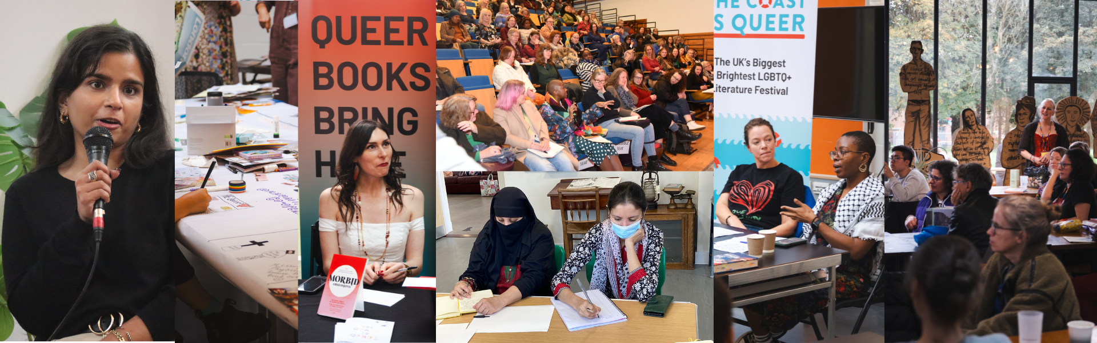

THE TRUSTEES WE ARE LOOKING FOR
We are looking for people who genuinely understand and promote diversity and intersectionality in engaging ways, who are ambitious for change, and who will bring fresh thinking to New Writing South as we grow and evolve.
We are seeking new Trustees with experience in one or more of the following areas:
- Finance / Business Development (including financial planning, oversight, fundraising, grants, or income generation)
- Human Resources / People (including organisational development, employment law, culture or wellbeing)
- Publishing (knowledge of the publishing sector, editorial processes, or industry networks.)
All Trustees should share a strong belief in the power of literature and a passion for supporting writers and storytelling as a force for connection and social change.
Previous Trustee experience is not required. We welcome people from a wide range of professional and lived experiences and will provide full training and induction for all new Trustees. Likewise, Trustees are not expected to be involved in day-to-day operations.
What we do need are Trustees who can help shape big-picture decisions: setting strategy, strengthening governance, supporting sustainability, and helping us grow the reach and impact of our work with writers and audiences. We are looking for people who enjoy asking thoughtful questions, offering challenge and guidance, and helping an organisation think boldly and responsibly about its future.
We will also be measuring our work against Arts Council England’s Investment Principles, and all Trustees will be given training to help oversee that objective.

OUR COMMITMENT TO DIVERSITY
We are clear that to drive our ambitions forward with confidence and integrity, New Writing South must reflect a diversity of voices at every level. We value lived experience and intersectional identities in all their forms and welcome applications regardless of perceived ability, age or gender. People from the Global Majority, who are queer, disabled and/or from working-class or low socio-economic backgrounds are particularly encouraged to apply. We especially welcome trans, neurodivergent and/or disabled applicants who are currently underrepresented on our Board. Please see our full Shortlisting Statement* below.

OUR CURRENT TRUSTEES
Anna Hayward – Chair of Trustees and strategist with over 30 years’ leadership across business and charities, who is also a novelist and mentor with deep personal ties to storytelling and community.
Abi Fellows – Literary agent with 20+ years’ publishing experience, championing marginalised writers, and governance experience through school literacy programmes.
Chris James – Director of Producing & Planning at Lyric Hammersmith Theatre with extensive experience developing new writing and producing new plays nationally and internationally.
Roy McFarlane – Poet, playwright and former youth/community worker whose published work and performance practice explore social justice, identity and the healing power of poetry.
Akila Richards – Award‑winning poet, writer and spoken word artist with a strong record of mentoring, facilitating creative events and cross‑disciplinary collaborations.
Vedrana Velickovic – Principal Lecturer in English Literature at the University of Brighton specialising in Queer, Black British, postcolonial and European literatures, and co‑founder of the DeCol Collective.

THE ROLE OF THE BOARD

The current Board of dedicated individuals bring a wide range of skills and experience from the creative, cultural and education sectors. Under the steer of Chair, Anna Hayward, Board members volunteer their time to guide the organisation strategically, meeting quarterly virtually and annually face-to-face. Papers including financial statements, activities round-ups, policy documents and project proposals are circulated in advance for the Board to discuss, question and feedback on at meetings. Everyone is invited to email in advance of meetings if anything in the Board papers is not clear. Trustees use their expertise to work with the Co-Directors on sub-committees or to help prepare papers or proposals. These are voluntary positions, but reasonable out-of-pocket expenses are paid.

The role of the Board is:
- to be accountable for the strategic direction of NWS
- to protect the financial stability of the organisation
- to have oversight of delivery against Arts Council England’s Lets Create strategy’s Outcomes and Investment Principles
- to ensure compliance with governance legislation and strive for best practice to safeguard the reputation and values of the NWS
- to guide and test the decision-making of the executive leadership including:
- vision, mission, aims, objectives
- impact and legacies
- business planning including fundraising, financial projections and accounts
- partnership development
- legal matters

In addition, the Board also:

- contributes to fundraising both actively and in an advisory capacity
- supports the Co-Directors and their team in developing and producing the best possible outcomes for our beneficiaries and stakeholders, particularly by contributing professional expertise, insight and connections
- contributes to the development of longer-term plans and projections, to better articulate our goals for the future while building a sustainable and thriving enterprise, more capable of projecting and therefore mitigating risk.

We realise that not everyone will have experience of every aspect of the Trustee role. Full training and briefings will be given and additional support provided as necessary to support new Trustees and enable full team working across the Board.

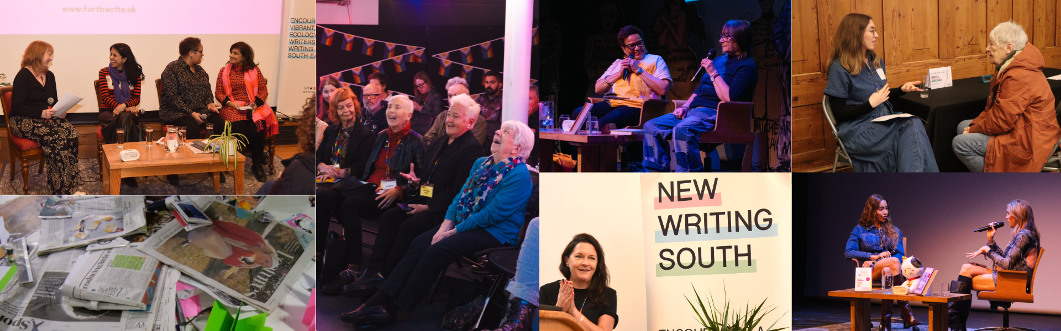

MORE INFORMATION ABOUT THE ROLES WE ARE SEEKING TO FILL

Finance / Business Development
Trustees with experience in finance and/ or business development should be able to contribute in some of the following ways:
- Be confident in financial planning, budgeting, cashflow management, and interpreting financial statements to support strategic decision-making.
- Provide oversight and guidance on risk management and long-term organisational sustainability.
- Offer insight and experience in fundraising, grant applications, sponsorship, partnerships, or income generation.
- Support the Board in making informed, values-led financial decisions that balance ambition with resilience.
- Advise on business strategy, growth opportunities, and income diversification to strengthen organisational stability.

Human Resources / People
Trustees with people-focused experience should be able to contribute in some of the following ways:
- Provide insight into organisational development, performance management, and team growth.
- Advise on creating and sustaining an inclusive, ethical, and supportive workplace culture.
- Help the Board ensure that people practices align with the organisation’s values and long-term strategic goals.
- Offer strategic guidance, HR governance, policies, and procedures. Knowledge of employment law would be an advantage.

Publishing
Trustees with publishing experience should be able to contribute in some of the following ways:
- Provide knowledge of editorial and commissioning processes within traditional, independent, or digital publishing.
- Offer insight into industry trends, challenges, and opportunities that affect writers and literary organisations.
- Share experience in audience development, marketing, distribution, or festival and event programming.
- Help the organisation strengthen networks and partnerships within the publishing sector.
- Advise on strategies to amplify under-represented voices and create meaningful pathways for writers.

TIME COMMITMENT

We hold four Board meetings a year on-line and one in-person Away Day where there is food and thinking time and a chance to look further ahead to develop our strategic thinking. Trustees are expected to attend Board development activities including training. Trustees may also be involved in sub-committees or one-off projects where they contribute their specific skills and expertise working with the Co-Directors and staff team between meetings. We estimate Trustees devote 4 - 6 days of time per year.

All Trustees must be UK-based and will be expected to attend a minimum of two out of four quarterly meetings. Meetings are on-line and last two hours with the exception of the annual half- or full-day Away Day. There will be additional ‘special events’, such as The Coast is Queer and Forthwrite festival, fundraisers and/or other events, to which Trustees are invited but not obliged to attend. These events offer the opportunity to really understand the work we do and get to know the staff team, alongside the writers and readers we work with.

The post is for a minimum of three years (one term) starting in late Spring 2026 and most Trustees serve two terms, or a maximum of six years.

EXPENSES

In compliance with charity law this is an unpaid voluntary position. Reasonable expenses may be claimed including travel costs, access support costs and child care costs for attending Board and other meetings.

BENEFITS OF BEING A NEW WRITING SOUTH TRUSTEE

Contributing to a cause that you believe in
We believe that arts, and literature in particular, are more important now than ever. Storytellers, poets and lyricists will be critical in shaping a bolder, braver, more equitable future. As an NWS Trustee, you will play a powerful role in working toward that future.

Professional development through strategic experience
Being a Trustee is a fantastic way to develop and hone the critical thinking, problem-solving and analytical skills needed for strategic oversight. Communication and people-skills including negotiating, empathising, listening and clearly communicating ideas and concerns are essential to positive, forward-thinking and efficient charity governance. Access to training supplied by NWS can also build confidence in your leadership role as a Trustee.

Building networks
Meeting people from diverse personal and professional backgrounds while working toward a common cause can open up professional and social networks, uncover career opportunities and create lifelong friendships. As a member of NWS Board of Trustees you will be joining a passionate group of writers, lecturers, business leaders and activists from diverse backgrounds and varied life experience.

Making New Writing South stronger and giving back to the community
Our Trustees help ensure the viability and sustainability of our organisation and contribute to achieving our mission, bringing benefits to the writing community and their readers in the South East. We could not do without them.

WANT TO KNOW MORE?

If you would like a one-to-one chat with our Chair, Anna Hayward, or one of our other Trustees to find out more about the roles or hear more about New Writing South, please contact Liam liam@newwritingsouth.com and he will arrange a phone call.

HOW TO APPLY
If you share our passion for writing and the contribution it can make to an open, diverse society and you think you would enjoy the challenge of helping us to build a stronger, inclusive, sustainable organisation, we would love to hear from you.

To apply for this role, please send us a letter (no longer than one side of A4), or a 4-minute video (MP3/MP4 video files) or voice memo (audio file) – whatever you are comfortable with. Tell us what you might bring to the Board, what motivates you, why you think championing the values and aims of our organisation is an exciting prospect, and any personal qualities, passions and ideas that you would bring as a Trustee of New Writing South. You are welcome to send your CV.

Please also contact liam@newwritingsouth.com if you have any other access requirements in order to apply.

APPLICATION

Please send your application to Co-Director Anna Jefferson at anna@newwritingsouth.com with ‘Trustee Application’ as the subject.

Please also complete this Equal Opportunities Monitoring Form. This information will be treated as confidential and used for shortlisting and statistical purposes only.

All applications and EO data will be deleted from our systems after the recruitment process is complete. You can find our Data Protection Policy here.

Interviews will be carried out virtually using online platforms.

* SHORTLISTING STATEMENT

People from certain groups are still currently under-represented in the arts nationwide, and we are committed to challenging and changing this.

People from the Global Majority, who are LGBTQIA+, disabled and/or from working class or low socio-economic backgrounds are particularly encouraged to apply for the role of Trustee.

The category of people in the Global Majority includes, but is not limited to, people of Black Caribbean, Black African, South Asian, East Asian, South East Asian, West Asian, Arab, Latinx, Jewish, Romany and Irish Traveller heritage.

The category of disabled people includes, but is not limited to, those who define as disabled people, as people with long term health conditions, as deaf, Deaf, neurodivergent or in relation to their health-related access requirements.

New Writing South does not anonymise applications and we reference equalities data for balancing our shortlist, as one of our scorable criteria is to add to the diversity of our Board.

This means when we shortlist, we always interview the highest scoring applicants and may also consider adding in a few lower scoring candidates.

This is because we understand that meeting repeated barriers might impact on the experience and employment opportunities people have been able to gather to date.

