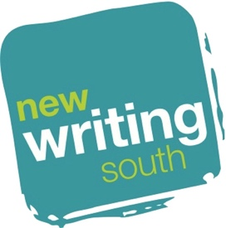

JOB APPLICANT EQUAL OPPORTUNITIES MONITORING FORM

NWS is committed to equality and diversity in its broadest sense. The information collected below is for diversity monitoring records only. It helps NWS and our funders understand who is engaging with our services.

Title of Job ………………………………………………………………………………………

Gender
Man Woman Non-binary Prefer not to say
Is your gender identity different to the sex you were assigned at birth?
Yes my gender is different No my gender is the same Prefer not to say
Age
16-24 25-34 35-44 45-54 55-64 65+
Prefer not to say
Ethnicity
White
White British White Irish Gypsy or Irish Traveller Any other White
Mixed/multiple ethnic groups
White and Black Caribbean White and Black African White and Asian
Any other Mixed / Multiple Ethnic
Asian/Asian British
Indian Pakistani Bangladeshi Chinese
Any other Asian background
Black/ African/ Caribbean/ Black British
African Caribbean Any other Black/African/Caribbean
Other ethnic group
Arab Any other ethnic group Prefer not to say Unknown

Disability
Do you consider yourself to be disabled according to the Equality Act 2010 definition – that is, you have a physical or mental impairment that has a ‘substantial’ and ‘long-term’ negative effect on your ability to do normal daily activities?
Yes No Prefer not to say

If you wish, you may provide more detail
Visual impairment Hearing impairment / Deaf Physical disability
Cognitive / Learning disability Mental health condition
Other long term / chronic conditions
What is your sexual orientation?
Heterosexual Gay woman/lesbian Gay man Bisexual
Other Prefer not to say
How did you find out about this job?
NWS email NWS Website NWS Twitter NWS Facebook
Arts Jobs Email from another organisation Word of mouth
Wired Sussex other organisation’s Twitter other organisation’s Facebook

Other – Please specify…………………………………………………………………..……..

This form uses Arts Council England monitoring criteria

